**Class 23/11/2021**

**Graph Theory**



**Theorem: Prove that a graph is bipartite if and only if all its cycles are of even length.**

**Proof:** Let us consider a bipartite graph G (V,E). So its vertex set can be partitioned into two disjoint subsets say V1, V2 where V1 $∪V2$ = $V$ and V1 $∩V2=∅$. Let us consider a cycle C $=\{u1,u2,u3,……,u_{m},u1\}$. Now for the sake of generality we consider u1 $∈V1$ then u2 $∈V2, Similarly$ u3 $∈$ V1, u4 $∈$ V2 and so on. Hence oddly subscripted vertices belongs to V1 and evenly subscripted vertices belongs to V2. As $u_{m}$ and u1 are adjacent. Hence $u_{m}$ $∈V2$. Hence m must be even. So we can conclude a bipartite graph has all its cycles are of even length.

To prove the converse, we consider a graph G(V,E) whose cycles are of even length. We are taking an arbitrary vertex u1 and we are creating a set of vertices V1 which contain all vertices which are at even length distant from u1. And also we include u1 in V1. We create another vertex set V2=V-V1. So V1 $∪V2$ = $V$ and V1 $∩V2=∅$. Now we claim that our partition is bipartite.

Let us consider two vertices say x, y $∈V1$ and let them be adjacent. Now we can create a cycle C1= {u1,…x,y,….u1}

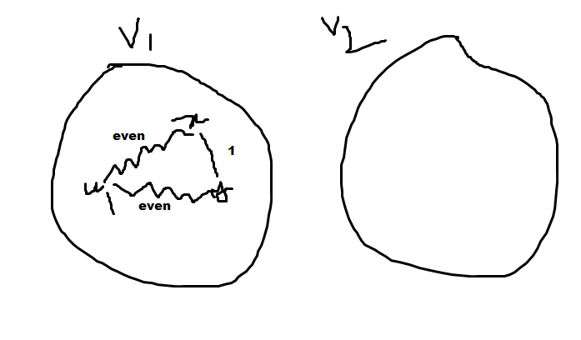

Now length of u1 to x=even and length of u1 to y=even. So if x, y are adjacent we can say that length of cycle C1 is odd. But it is a contradiction as all cycles of G are of even length. Hence x, y can’t be adjacent. So for any pair of vertex in V1 is not adjacent.

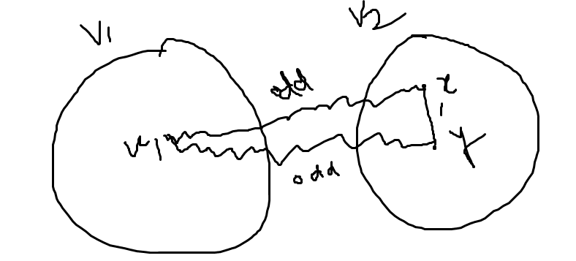

Let us consider two adjacent vertices x,y $∈V2$. Now length of u1 to x is odd else x must belong to V1.Similarly length of u1 to y is also odd. Now the cycle C2={u1..x,y…u1} must be of even length. So x and y must not be adjacent. No two vertices of V2 is adjacent.

Hence the graph G is bi-partite. (Proved).

**Walk:** A finite alternating sequence of vertices and edges beginning and ending with vertices, such that each edge is incident with the vertices preceding and following it.

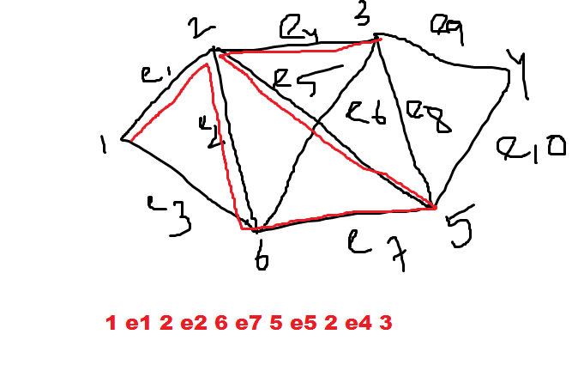

**Closed walk**: A walk whose beginning and end vertices are same is called closed walk.

**Path:** An open walk in which no vertex appears more than once is called a path. The number of edges in a path is called length of the path.

**Closed path or circuit:** A closed walk in which no vertex appears more than once except the beginning or end vertex.

**Connected Graph:** A graph G (V, E) is connected, if there exist at least one path between any pair of vertices of V. If not the graph is **disconnected**.

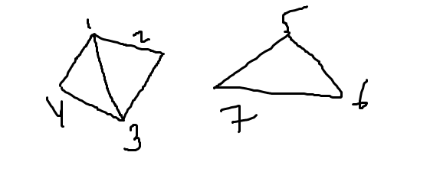

Disconnected graph G

A disconnected graph has many connected components.

**Theorem: A simple graph with n vertices and k components can have at most $\frac{(n-k)(n-k+1)}{2}$ edges.**